📊 Sales and Profit Analysis Dashboard
for Nassau Candy Distributor
Submitted By
Name : PRIYANKA
College: SARASWATI GROUP PF COLLEGES
Branch: B.TECH(AIML)
Internship: MACHINE LEARNING
Date: 22 JUNE 2026

1. Introduction
The Nassau Candy Distributor Sales and Profit Analysis Dashboard is a data analysis project developed using Python and Streamlit.
The main purpose of this project is to analyze the sales and profit performance of Nassau Candy Distributor and provide business insights through tables and graphical visualizations.
This dashboard helps users understand which products, divisions and regions are performing better and contributing more to profit.

2. Objectives
The objectives of this project are:
- Analyze the sales data of Nassau Candy Distributor.
- Calculate the profit margin.
- Identify the Top 10 Most Profitable Products.
- Analyze Division-wise Profit.
- Analyze Region-wise Profit.
- Visualize business insights using charts.

3. Technologies Used
The following technologies are used in this project:
- Python
- Pandas
- Matplotlib
- Streamlit
- CSV Dataset

4. Dataset Description
Dataset Name:
Nassau Candy Distributor Dataset
Important Columns:
- Product Name
- Gross Profit
- Division
- Region
The dataset contains information regarding products, sales, profits and regional distribution.

5. Dashboard Features
The dashboard includes:
- Total Sales
- Total Profit
- Total Orders
- First Five Rows of Dataset
- Profit Margin
- Top 10 Most Profitable Products
- Top 10 Products Chart
- Division-wise Profit Analysis
- Division-wise Profit Chart
- Region-wise Profit Analysis
- Region-wise Profit Chart

Dashboard Overview: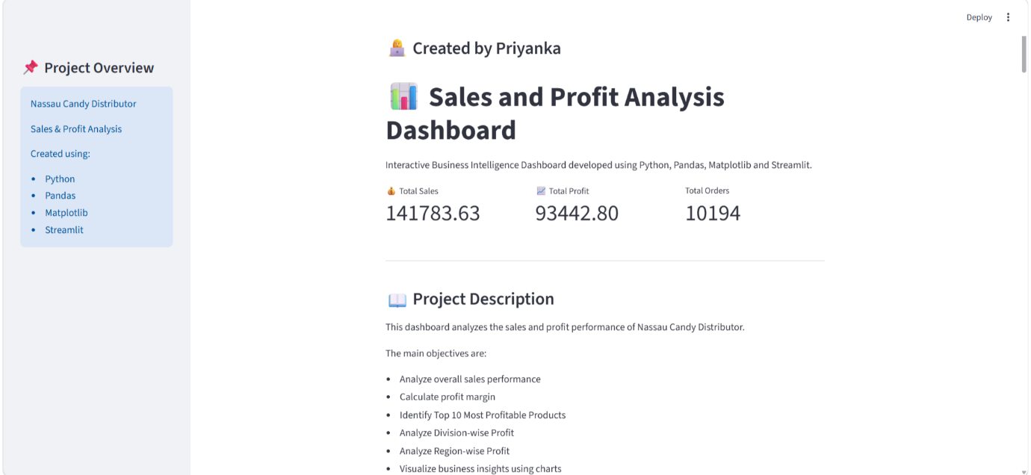

Profit Margin Analysis: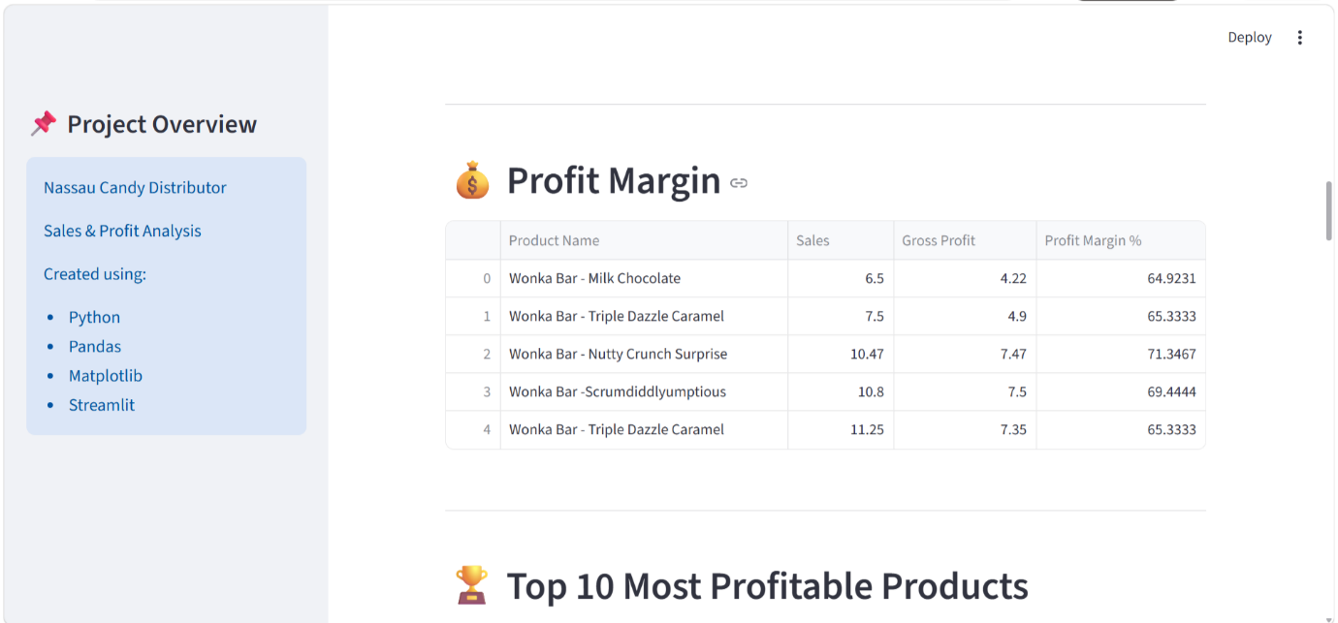
Top 10 Most Profitable Products: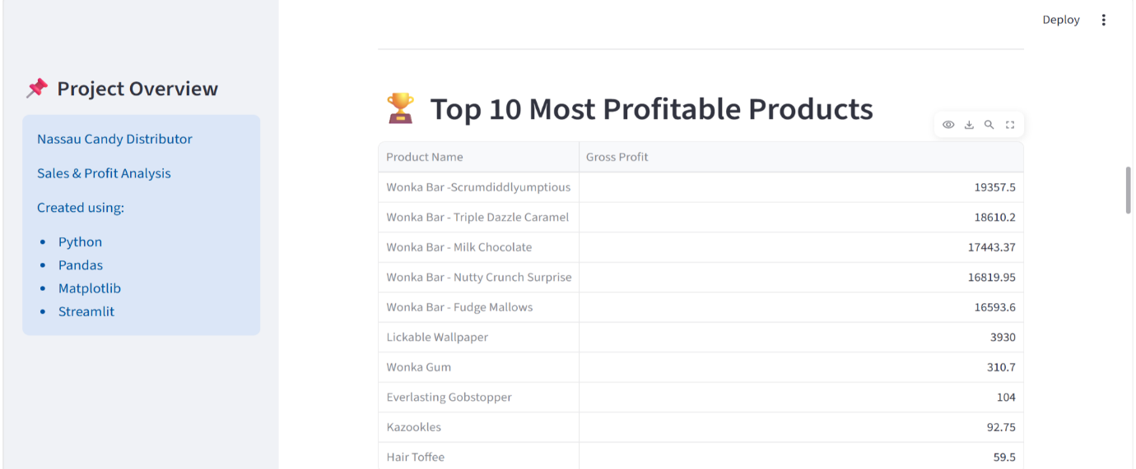
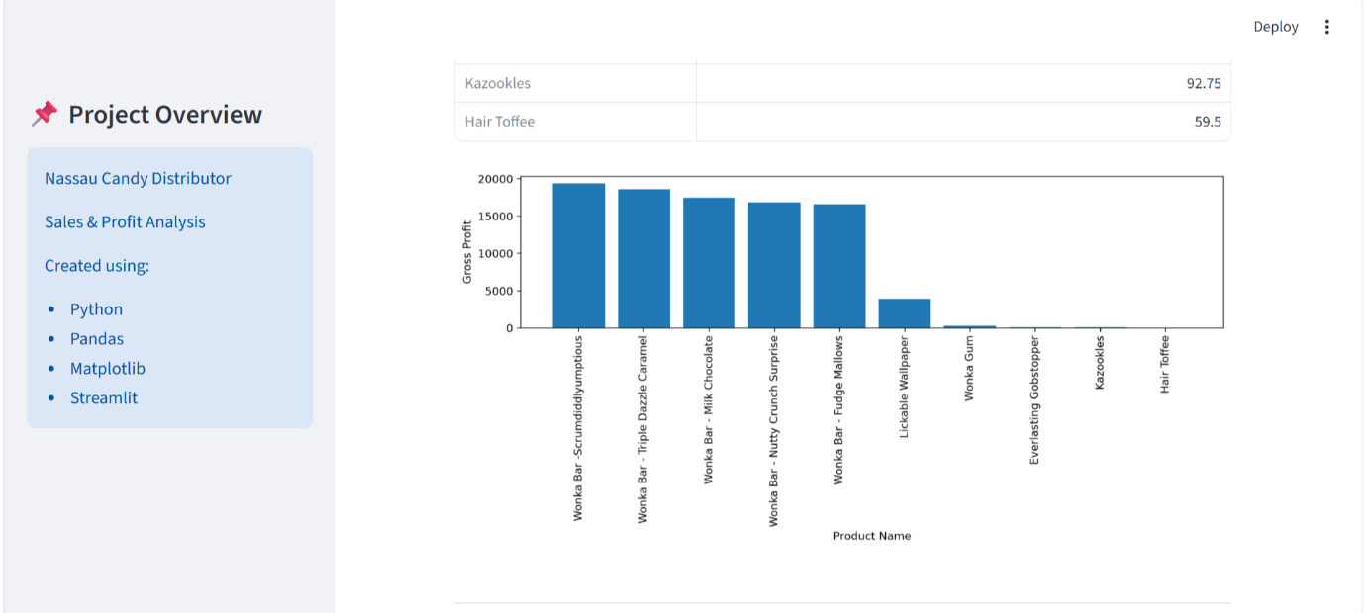
Division-wise Profit Analysis: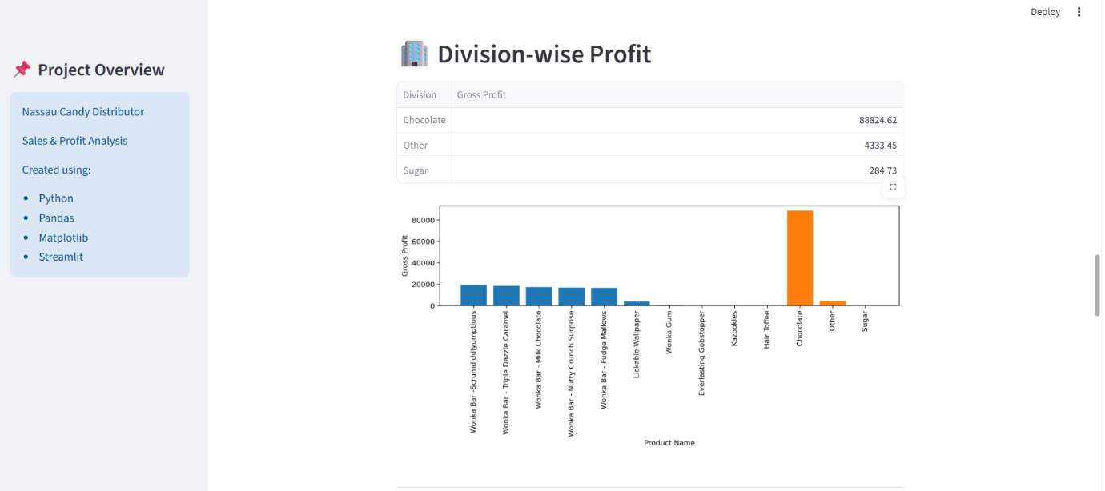

Region-wise Profit Analysis: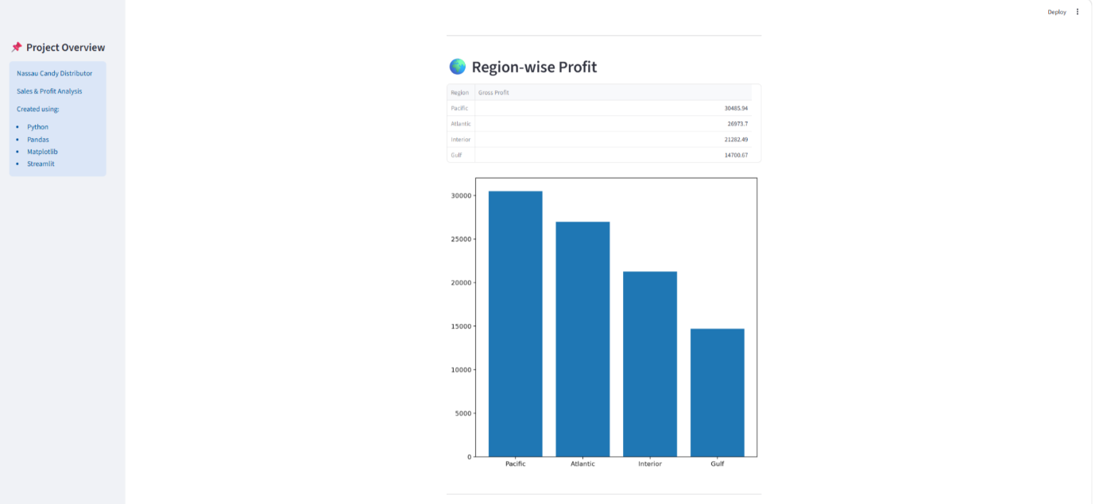

6. Results
The dashboard successfully provides business insights regarding profitable products, divisions and regions.
The charts make the analysis easy to understand and help in better business decision making.

7. Conclusion
This project demonstrates how Python can be used for business data analysis and visualization.
The Nassau Candy Distributor Dashboard provides meaningful insights about sales and profitability and presents them in an interactive and user-friendly manner.

